Refrigerator Universal Inverter Board - New Upgraded Version
User Manual

Note: For Midea-GMCC refrigerator inverter compressors, the model follows the pattern of DZ+Numbers+Z+** (Z Series); please consult customer service.
The universal inverter board is suitable for variable-frequency refrigerators below 680L, compatible with a two-wire or single-wire pulse signal line for communication with the mainboard, effectively solving the problem of universal compatibility for inverter compressor drive boards; it addresses the concerns of many maintenance technicians.
一、Conditions for Using the Universal Board:
1、The inverter board is suitable for refrigerators where the mainboard and the inverter board are separate, not integrated into one board.
2.There are two pulse signal wires (two communication signal lines) between the inverter board and the mainboard. If there are two signal wires, it can be determined as this mode.
3.There is a single pulse signal wire (one communication signal line) between the inverter board and the mainboard. If there is one signal wire, it can be determined as this mode.
二、Types of Universal Boards:
1.Universal Inverter Board:
Pulse Frequency Signal Version: Requires the mainboard to provide pulse signals (communication with the mainboard is through two signal wires), and can replace the original inverter control board on the market.
Single-wire Control Signal Version: This uses a single-wire control signal, which is a strong electrical signal output by devices such as the thermostat or mainboard relay.
2.Maintenance and Testing Board: By connecting to the compressor, it allows the compressor to run upon powering on, with a rotational speed equivalent to that of a fixed-frequency compressor. It can be used to test the compressor alone or to test other brushless motors (with a power below 280W).
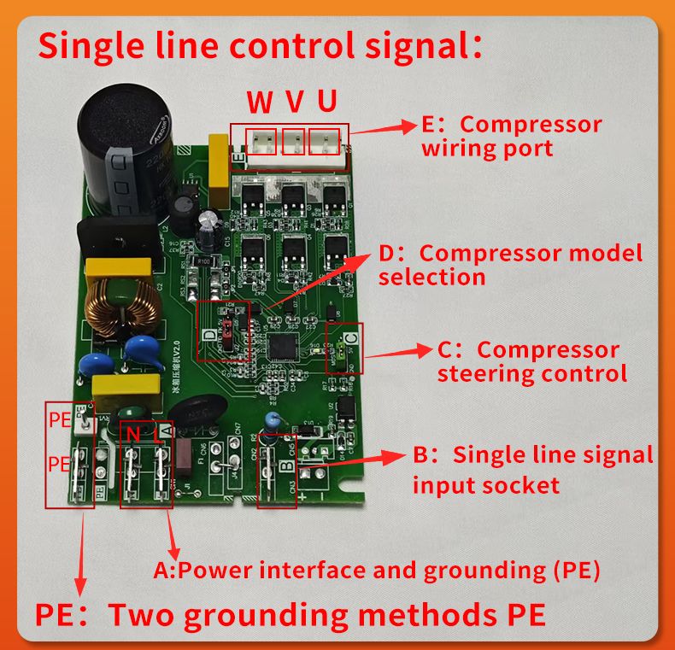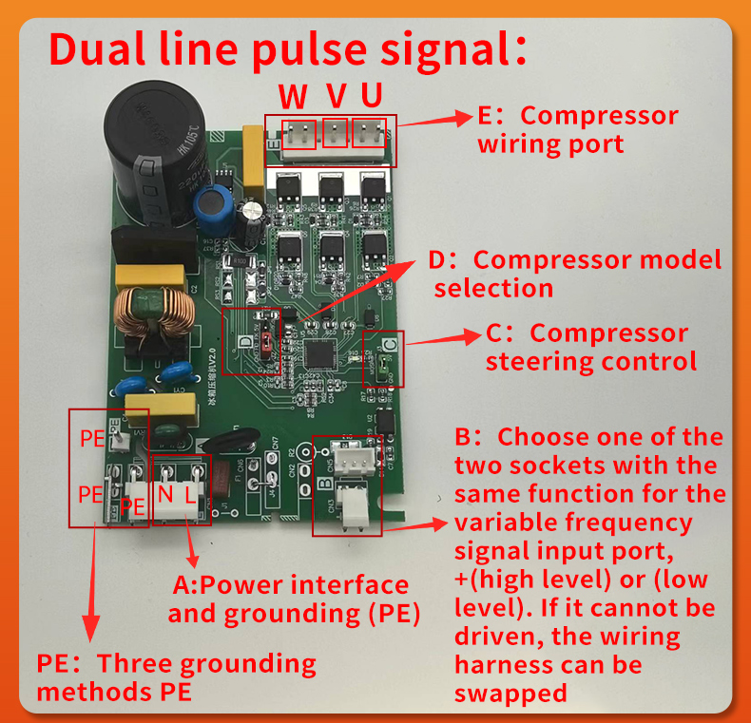
三、Wiring Port Instructions
PE Identification: Several grounding methods are provided, which can be selected according to the grounding type of the original refrigerator model.
A Identification: This represents the AC 220V power supply LN and PE grounding.
B Identification: Pulse Frequency Signal: Two types of interface connections are provided here: VH type and XH type; "+" corresponds to high level, "-" corresponds to low level; if the drive fails, check if the high and low levels are reversely connected here. Single-wire Control Signal: This is a single-wire control signal, which is a strong electrical signal output by devices such as the thermostat or mainboard relay.
C Identification: Note that the compressor wiring should be consistent with the original inverter board's U, V, W terminals. If the original inverter board cannot be confirmed, please follow the method below to identify the wiring harness: A green shorting cap has been added here by the manufacturer to change the direction of compressor rotation. When the shorting cap is added as shown in the diagram below during manufacturing, the compressor will rotate clockwise.
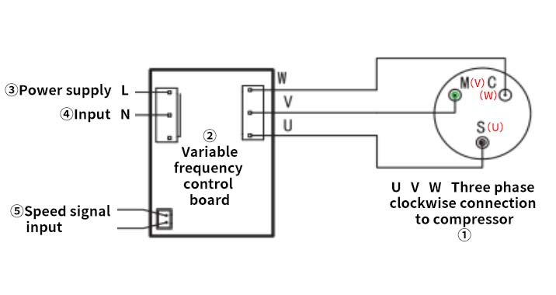
Note:
- For most compressor brands, the connection between the universal inverter board and the compressor harness should be confirmed according to the above diagram.
- For certain foreign brands such as Embraco, Panasonic, and Samsung, the compressor operates in a counterclockwise direction. In this case, after wiring according to the above diagram, remove the green shorting cap at position C or exchange any two of the three harness wires U, V, and W as shown in the diagram.
D Identification:
- The red wiring cap labeled "D" (or red plug cap) is compatible with various brands and models of refrigerator variable-frequency compressors. For compressor models listed in the following table, the red plug cap should be removed. For models not listed, the red plug cap should be retained initially. However, if the rotational speed is too low or there are abnormal startup issues, the red plug cap should then be removed.
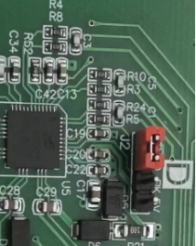 | brand | compressor model
 | 万宝华光HUAGUANG | VETB72、VETB72L、VETB90、VETB90L、VETB110、VETB110L、VETZ72、VETZ72L、VETZ90、VETZ90L、VETZ110、VETZ110L、VETX72、VETX72L、VETX90、VETX90L、VETX110L、VETY72、VETY72L、VETY90、VETY90L、VETY110、VETY110L、VEKY60、VEKY60L、VEKY70、VEKY70L、VEKY90、VEKY90L、VEKZ60、VEKZ60L、VEKZ70、VEKZ70L、VEKZ90、VEKZ90L、VEKB60、VEKB60L、VEKB70、VEKB70L、VEKB90、VEKB901、VEXK60、VEXK60L、VEXK70、VEXK70L、VEXK90、VEXK90L
 | 加西贝拉jiaxipera | VTX1116Y、VTH1113Y、VMH1113Y、VMH1111Y、VTB1113YL、VTB1111YL、VTB1113Y、VTD1111Y、VTD1113Y、VMU1111Y、VMU1113Y、VTB1116YL、VTB1113YA、VNT1113Y、VNC1113Y、VNX1113Y、VNX1116Y VNF1113Y
 | 华意HUAYJ | HVD70MS、HVD70MXa、HVD70MT、HVD70MTa、HVD90MTa、HVD90MX、HVD90MXa、HVS90MTa、HVS90MTa、IVM45MKa、IVM45MXa、VM58MKa、VM58MTa、IVM58MSa、HVM58MX、HVM70MK、HVM70MTa、HVM70MSa、HVM70MXa、IVM70MD、IVM70ME、IVM70MF、HVM90MK、HVM90MTa、HVM90MSa、IVM90MXa、HVM90MD、IVM90ME、VM90MF、HVM90MF*、HVM100MK、HVM100MT、HVM100MS、IVM100MX、HVM100MD、IVM100ME、HVM110MK、HVM110MT、HVM¹10MS、HVM¹10MX、HVM¹10MD、HYM¹10ME
 | LG | BMG089NHMV、BSA075NJMV、BMG110NHMV、BMG110NAMV、BMA069LCMV、BMA069LCMV、FMA088NCMA、FMC088NAMA、FMA102NAMA、FMA102NBMA、FLA150NBMA、FLD165NCMA、FLD165NBMA、FLE165NAMA、BMK110NAMV、BMK090NAMV、BMG089NHMV、BSA075NBMV、BMA120NAWV、BMG110NHMV、BMA069LAMV、BMA069LCMV
 | 美芝GMCC | DZ+Number+A+** (A Series)
 | 钱江Qianjiang Compressor | VFM52YL、VFC70YL
 | 松下Panasonic | ERI120E13DCH TDK91E18PBG

四、Universal Board Fault Codes

Fault Indicator Light | protection status
Flash once | Hardware Overcurrent
Flash twice | Software Overcurrent
Flash three times | Overvoltage
Flash four times | Undervoltage
Flash five times | Phase Loss
Flash six times | Stalled Rotor
Flash ten times | Chip High Temperature Warning
Flash fourteen times | Overpower Protection
Flash sixteen times | Current Bias Protection

